* Create placements groups.
  + There two ways to create placements groups
    - While creating instance.
    - There Is an option for the placement’s groups.
* Search for the placement’s groups in the search bar.

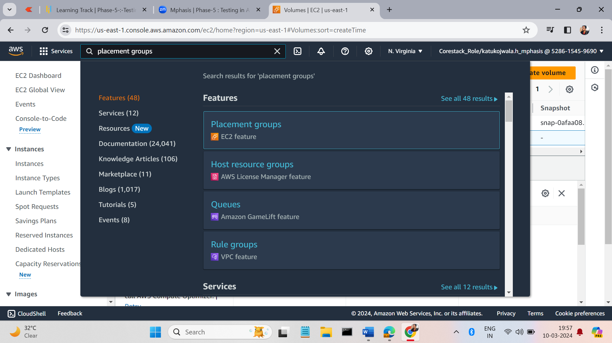

* We have a button like create placement group top right side of the page.

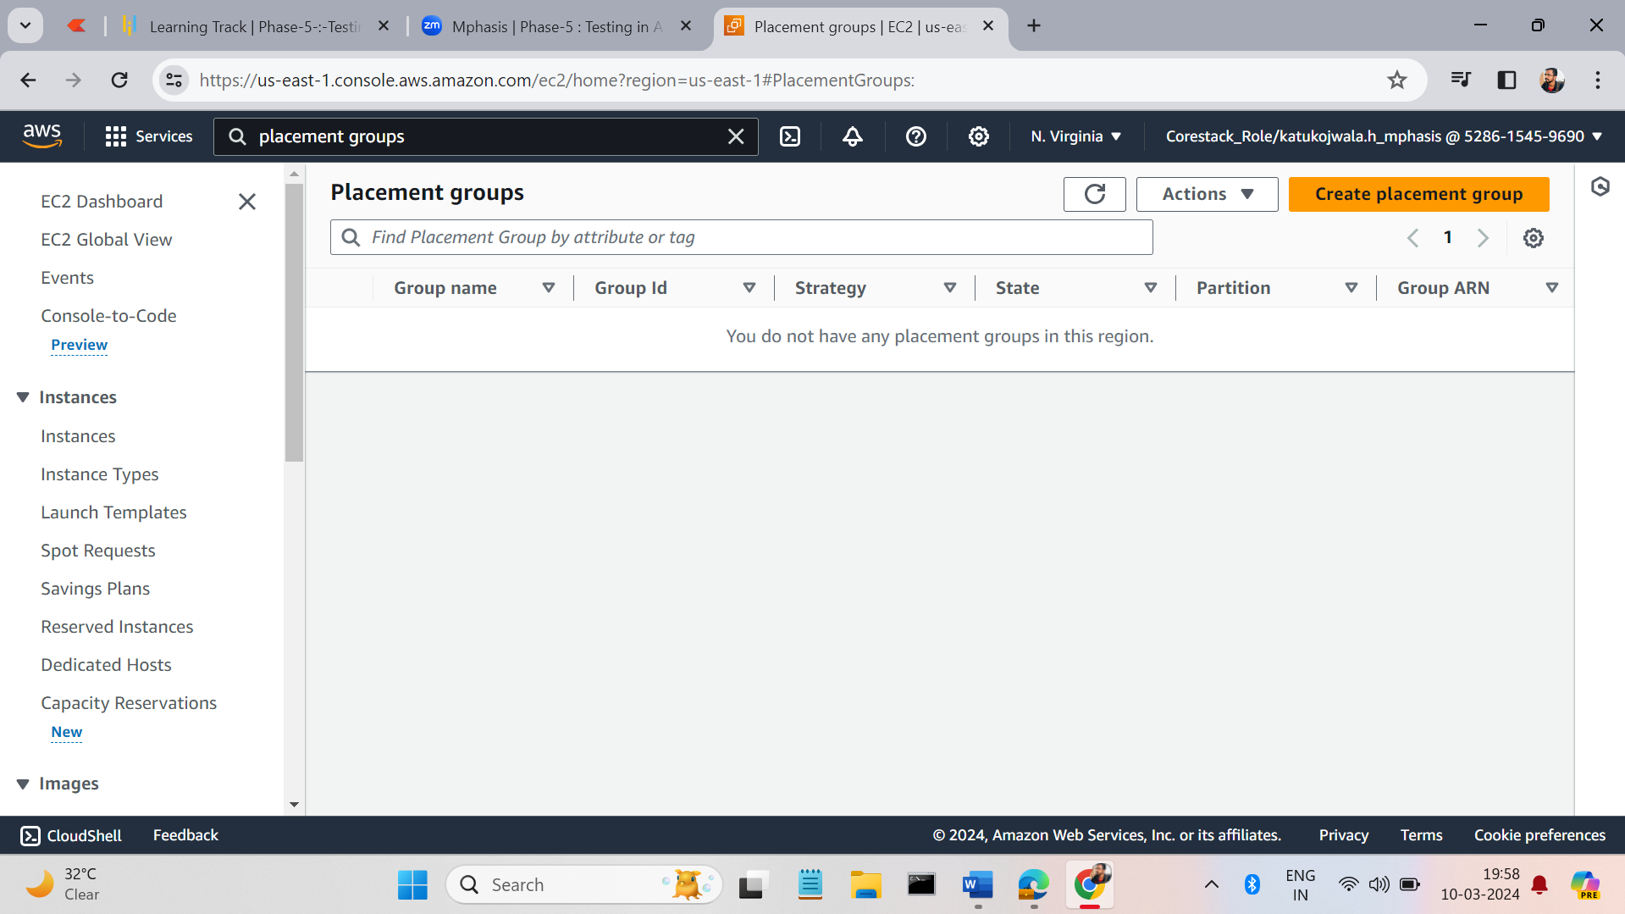

* Give the name of the placement group, placement strategy and tags name(optional).

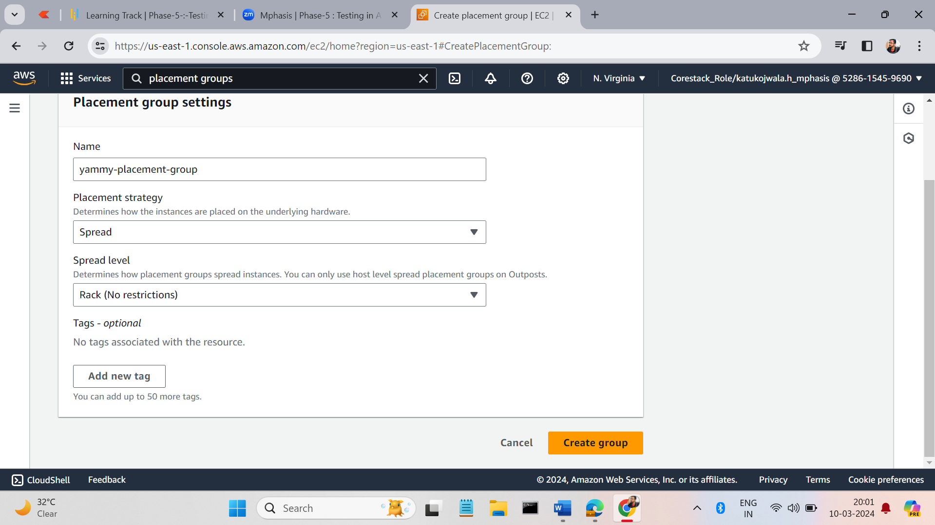

* Click on the create button.

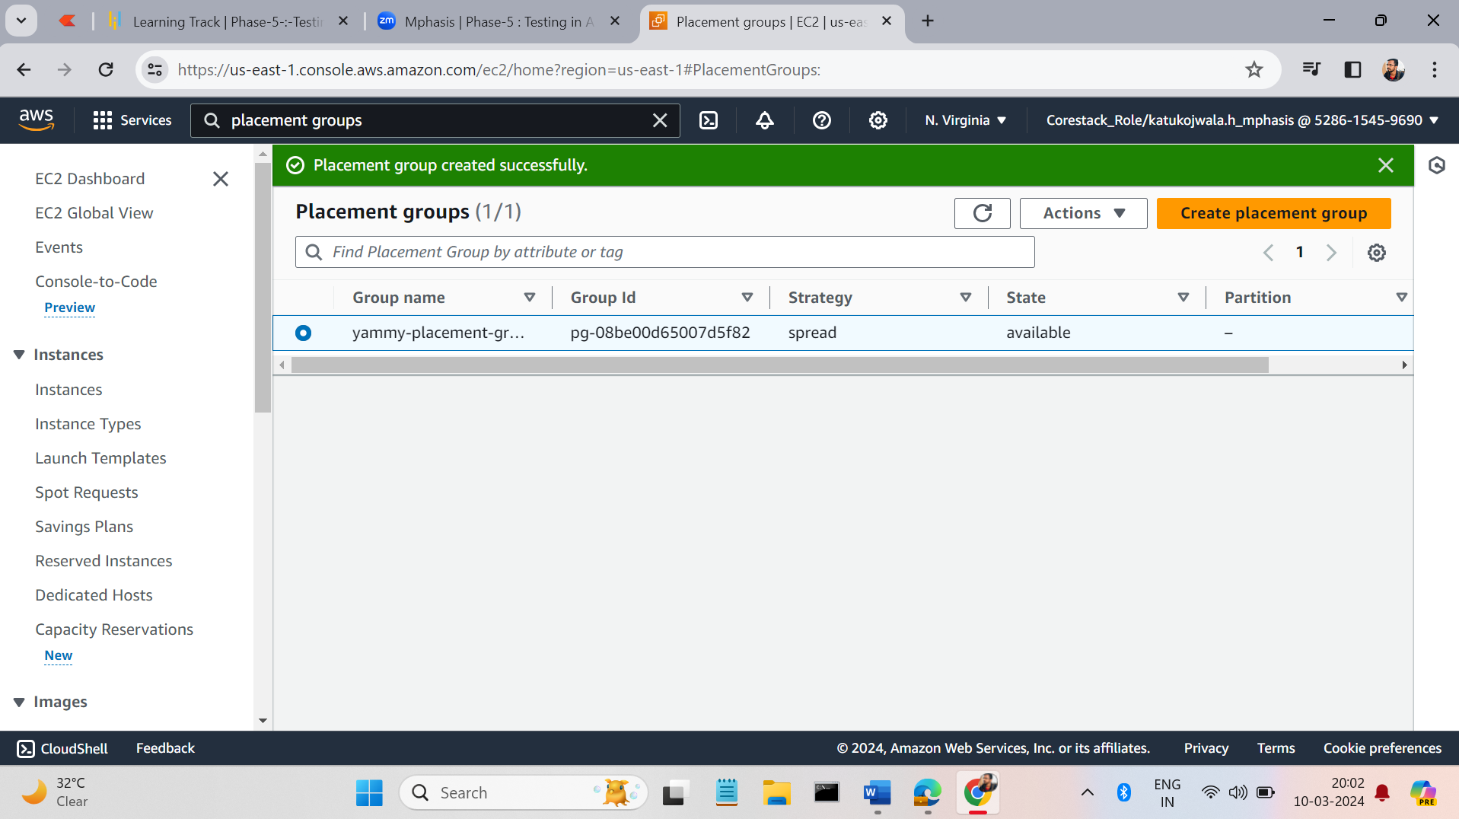

* Create and instance give the following details. In advance we have a option like add placement groups, give the details of placement group what we created.

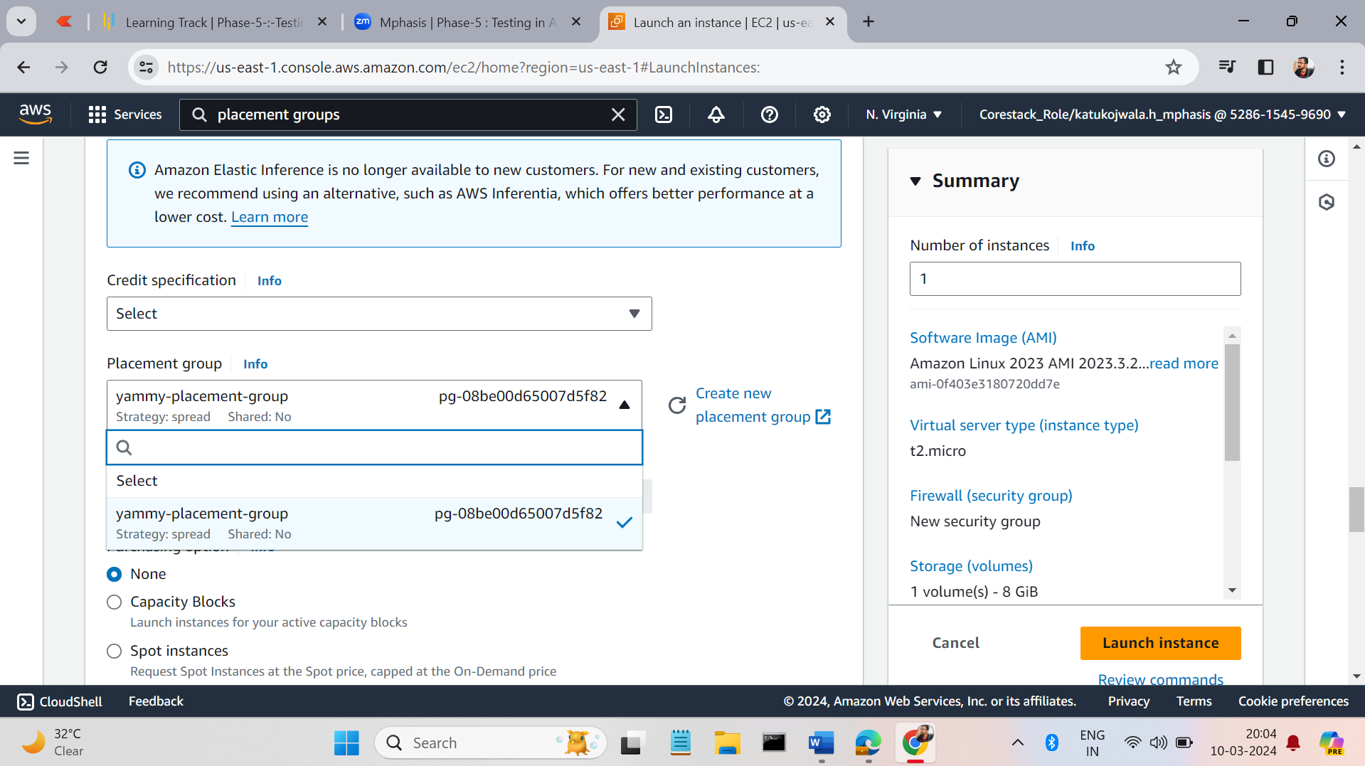

* Click on the launch instance.

